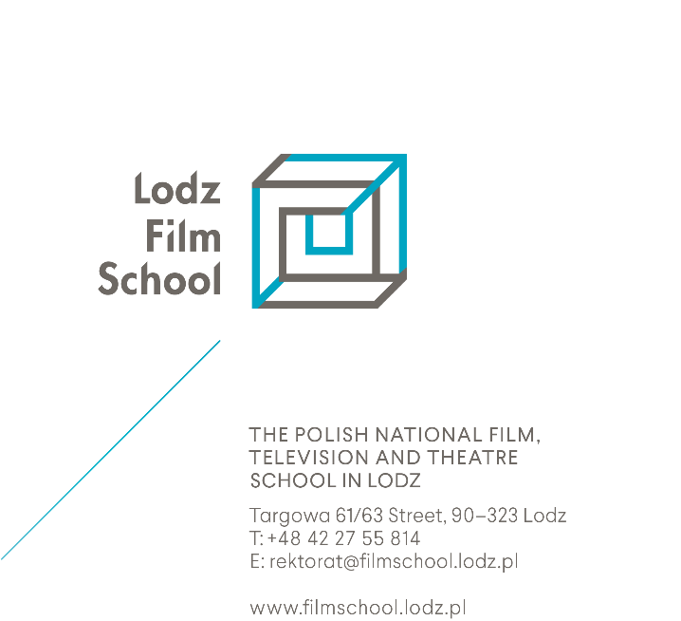
Candidates eligible to studies tuition-free:
- Citizens of the European Union, European Economic Area, Switzerland
and their family members who live in Poland;
- Holders of a permanent residence permit or a long-term EU-residence permit;
- Holders of a temporary residence permit issued for the purpose of family reunification;
- People granted refugee status in Poland;
- People granted temporary protection or subsidiary protection in Poland;
- Holders of a state certificate in Polish as a foreign language (C1 level
or above);
- Holders of a valid Pole’s Card (Karta Polaka)
- Relatives of a Polish citizen: their spouse, children or parents,
who live in Poland.

*** If you are entitled to free studies, you have to take the exam with Poles.***

